18. All HTML elements occupying a rectangular area are called a box.The box may be in the screen or other visual output medium. Every box contains a nested collection of
rectangular subareas. Write a HTML program for box model.
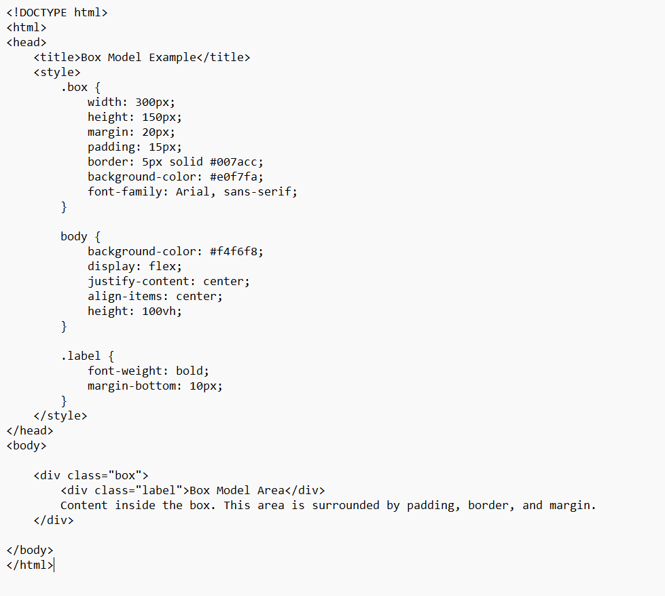output
